Alcohol Consumption and Academic Performance: A study among Portuguese secondary school students

Soubhik Chakraborty

[schakraborty@falcon.bentley.edu](mailto:schakraborty@falcon.bentley.edu)

Master’s in Business Analytics

ST625 – Quantitative Analysis for Business

Prof. Moinak Bhaduri

Bentley University

**Abstract**— According to the study “Prevent Harmful Use of Alcohol” (TPN/Lusa, 2021), Portugal people over age of 15 consumes on an average 12 litres of pure alcohol annually. Academic related statistics puts Portugal in Europe’s tail end due to its high failure rates of students in core subjects like Mathematics and Portuguese language. Therefore, exploring a relationship between secondary school students’ quality of learning and alcohol usage is imperative. Previous study has explored Math and Portuguese grades individually, however, performance of students taking both the subjects is not fully explored in conjunction. A multiple linear model predicting final grade of Portuguese language is built considering the final Math grade of the students alongside other variables. Though student prior evaluations (G1&G2 scores) greatly influence their final grade, daily alcohol consumption, higher education aspiration, math’s score and absenteeism of classes explains quite a lot about student’s performance depending on the age, gender, and school.

Linear Regression model tries to fit a straight line attempting to explain the data and predict unseen data within the domain of trained dataset. The data pass the normality test and satisfies the assumptions of linear model.

**Index Terms**— Alcohol Consumption effecting Student Academics, Business Intelligence in Education, Linear Regression Model

**1 INTRODUCTION/MOTIVATION**

According to NIAAA publishing on Alcohol’s Effects on Adolescents (Spear, 2003) early usage of alcohol has a detrimental effect both physiologically and psychologically. Therefore, analysis of student’s academic performance is another measure of impact of alcohol.(Cortez & Silva, 2008) has done first in-depth study of this data. We found a Multiple Linear Regression, modelled only on math scores explains about 21% of the students while around 32% students’ Portuguese language score can be explained by the same. A more coherent understanding evolves when students taking both the classes are simultaneously considered in a linear regression setup predicting their Portuguese language score. Only the final grades are considered because previous scores though have a bearing, violates some of the liner regression model assumptions, and hence dropped. This analysis focuses on whether alcohol drinking habits have any statistically significant effect on students’ learning abilities while taking other 33 potential influences like parents’ job and education, family dynamics, demographic, studying and travel time, school, age & gender into consideration.

This report has five sections. Section 2 details about the survey data, employed regression methodology and various one-to-one comparisons of G3 Portuguese score with highly correlated predictors & categorical variables. Section 3 captures the best fit regression model predicting G3 Portuguese score between zero (0%) to twenty (100%), derived from the representative data of the Portuguese students. Section 4 dives into inferences of the model detailing its strength/weakness and intuition. Section 5 draws conclusion empirically and calls out future improvements.

**2 THE DATA SET**

The data is collected from two public schools of the Alentejo region in Portugal during the academic year 2005-2006, which is donated to Public Domain (Pagnotta & Amran, 2016) under CC0 license nearly 6 years ago from the date of this report. The data is collected from two sources viz. school report card and questionnaires complementing missing information in the score card. Nearly 788 students were surveyed out of which 111 were discarded due to lack of identification required to link it with report card. The data obtained has student’s Math and Portuguese score separated out with 395 and 649 records. Considering all the students attending both the classes (by joining the two datasets) there are 370 records in common, of which this analysis is done. It is learnt from the data collection background that during preprocessing some features were dropped due to lack of discriminative values like family income is rarely reported (due to privacy issues) or 100% of the student reporting owning a personal computer at home. Table 1 Description of Variables in Student Data elaborates on the various parameters data was collected. The passing score of any course is 10 and that is considered separately as an independent variable for Math & Portuguese separately.

Figure 1 Students scores and alcohol consumption

Figure 2 Students of various age groups and study time

The categorical variables are binary encoded as following:

|  |  |  |
| --- | --- | --- |
| Attribute | Encoding |  |
| **school** | MS  GP 0  MS 1 |  |
| **sex** | M  F 0  M 1 |  |
| **address** | U  R 0  U 1 |  |
| **famsize** | LE3  GT3 0  LE3 1 |  |
| **Pstatus** | T  A 0  T 1 |  |
| **schoolsup** | yes  no 0  yes 1 |  |
| **famsup** | yes  no 0  yes 1 |  |
| **activities** | yes  no 0  yes 1 |  |
| **nursery** | yes  no 0  yes 1 |  |
| **higher** | yes  no 0  yes 1 |  |
| **internet** | yes  no 0  yes 1 |  |
| **romantic** | yes  no 0  yes 1 |  |
| **paid.math** | yes  no 0  yes 1 |  |
| **paid.portugese** | yes  no 0  yes 1 |  |

|  |  |
| --- | --- |
| Attribute | Encoding |
| **Mjob** | | |
| health other services teacher  at_home 0 0 0 0  health 1 0 0 0  other 0 1 0 0  services 0 0 1 0  teacher 0 0 0 1 | | |
| **Fjob** | | |
| health other services teacher  at_home 0 0 0 0  health 1 0 0 0  other 0 1 0 0  services 0 0 1 0  teacher 0 0 0 1 | | |
| **reason** | | |
| home other reputation  course 0 0 0  home 1 0 0  other 0 1 0  reputation 0 0 1 | | |
| **guardian** | | |
| mother other  father 0 0  mother 1 0  other 0 1 | | |

**3 THEORY AND METHODS**

Regression, a form of predictive modelling, investigates the relationship between dependent and independent variable. The model can be built with an aim to explain past events or with an interest to predict future event under similar circumstances within the sample data domain. Simple or Multiple Linear Regression is modelled from the samples using a best fit straight line. A second or higher order polynomial equation can also be built for best approximation of the relationship in Linear Regression with special care to not overfit the model to the sample data.

A straight-line equation with one variable takes the form of $y=mx+b$ where $y$ is dependent on values of $x$. $b$ is called $y-intercept$ and $m$ is coefficient of $x$ describing the rate of change in $y$.

Multiple linear regression model takes the general form as

$$y= β_{0}+β_{1}x_{1}+β_{2}x_{2}…..β_{n}x_{n}+ϵ$$

Where $β_{0}$ is the $y-intercept$ and $β_{1},β_{2}…. β_{n}$ are the coefficients of $x_{1},x_{2}…. x_{n}$ respectively describing the true population parameters. While the known parameters explain the dependent variable $y$, $ϵ$ is the noise i.e., unknown parameters that explain $y$ fully completing the equality equation above. The unknowns thus can be attributed to error in the model more formally called standard error.

While the $β_{n}$ represents the true population coefficients of the parameters which is often unknown in practice, model fitted using samples are estimates of the true population coefficients. Therefore, linear regression model is derived from the representative uniform random samples drawn from the population. It is indicated using a hat (${\hat{β}}_{n}$) over the coefficients.

Fitted model thus takes the following form:

$$\hat{y}={\hat{β}}_{0}+{\hat{β}}_{1}x_{1}+{\hat{β}}_{2}x_{2}…. {\hat{β}}_{n}x_{n}$$

Where $\hat{y}$ is the estimated response variable from the estimated ${\hat{β}}_{0} y-intercept$ and ${\hat{β}}_{1}, {\hat{β}}_{2}…{\hat{β}}_{n}$ are the estimated coefficients of $x_{1},x_{2},…x_{n}$ research variables.

In the above model, there are certain assumptions for the standard error while evaluating how well the model describes the true relationship.

1. The mean of the probability distribution of $ϵ$ (standard error) is zero. That is, the average of errors (difference between sampled $y$ and estimated $\hat{y}$) over a long series for each independent variable setting is zero.

Table 1 Description of Variables in Student Data

|  |  |
| --- | --- |
| Attribute | Description (variables) |
| **school** | student's school (binary: 'GP' - Gabriel Pereira or 'MS' - Mousinho da Silveira) |
| **sex** | student's sex (binary: 'F' - female or 'M' - male) |
| **age** | student's age (numeric: from 15 to 22) |
| **address** | student's home address type (binary: 'U' - urban or 'R' - rural) |
| **famsize** | family size (binary: 'LE3' - less or equal to 3 or 'GT3' - greater than 3) |
| **Pstatus** | parent's cohabitation status (binary: 'T' - living together or 'A' - apart) |
| **Medu** | mother's education (numeric: 0 - 4[1]) |
| **Fedu** | father's education (numeric: 0 - 4a) |
| **Mjob** | mother's job (nominal[2]) |
| **Fjob** | father's job (nominalb) |
| **reason** | reason to choose this school (nominal: close to 'home', school 'reputation', 'course' preference or 'other') |
| **guardian** | student's guardian (nominal: 'mother', 'father' or 'other') |
| **traveltime** | home to school travel time (numeric:[3]) |
| **studytime** | weekly study time (numeric: 1 - <2 hours, 2 - 2 to 5 hours, 3 - 5 to 10 hours, or 4 - >10 hours) |
| **failures** | number of past class failures (numeric: n if 1<=n<3, else 4) |
| **schoolsup** | extra educational support (binary: yes or no) |
| **famsup** | family educational support (binary: yes or no) |
| **paid** | extra paid classes within the course subject (Math or Portuguese) (binary: yes or no) |
| **activities** | extra-curricular activities (binary: yes or no) |
| **nursery** | attended nursery school (binary: yes or no) |
| **higher** | wants to take higher education (binary: yes or no) |
| **internet** | Internet access at home (binary: yes or no) |
| **romantic** | with a romantic relationship (binary: yes or no) |
| **famrel** | quality of family relationships (numeric: from 1 - very bad to 5 - excellent) |
| **feetime** | free time after school (numeric: from 1 - very low to 5 - very high) |
| **goout** | going out with friends (numeric: from 1 - very low to 5 - very high) |
| **Dalc** | workday alcohol consumption (numeric: from 1 - very low to 5 - very high) |
| **Walc** | weekend alcohol consumption (numeric: from 1 - very low to 5 - very high) |
| **health** | current health status (numeric: from 1 - very bad to 5 - very good) |
| **asences** | number of school absences (numeric: from 0 to 93) |
|  |  |
| *These grades are related with the course subject, Math or Portuguese:* | |
| **G1** | first period grade (numeric: from 0 to 20) |
| **G2** | second period grade (numeric: from 0 to 20) |
| **G3** | final grade (numeric: from 0 to 20, output target) |
|  |  |

1. The variance of the probability distribution of $ϵ$ is constant across multiple experiments and all settings of independent variables.
2. $ϵ$ is normally distributed.
3. The errors are mutually independent across different observations. That is one error in $\hat{y}$ does not effects next estimation of $y$.

Null Hypothesis of the model:

$H_{0}: {\hat{β}}_{1}={\hat{β}}_{2}…={\hat{β}}_{n}=0$

$H_{a}:Atleast one of the \hat{β}≠0$

Quality of the model is mainly evaluated considering the above hypothesis. Independent variables are introduced one at a time to find the best fit model. For every iteration overall model quality is compared using F-statistic and its p-value tested at $α=.05$ failing to reject Null Hypothesis, otherwise the model is discarded. On successful determination of the usefulness of the model p-value of each variable is verified for its significance level to the overall model. Higher $R_{a}^{2}$ (adjusted coefficient of determination), Low MSE (Mean Squared Error) & Low AIC (Akaike Information Criterion) were the primary driving factors to retain the model with newly added variable or discarding it in favor of the previous. PRESS value (Predictive REsidual Sum of Squares) and $R_{jack}^{2}$ (Jack Knife coefficient of determination) are then compared to determine relatively which is the better model. Multicollinearity is tackled during the variable selection process after dropping already known collinear variables G1/G2 Math and G1/G2 Portuguese scores utilizing the fact that final grades are derived from these variables. Through experimentation it was observed that these variables were suppressing the actual causal relation with other more intuitive variables offering little explanation of their own existence. In the linear regression modelling method avoidance of multicollinearity is a necessity to reduce noise.

**4 DATA ANALYSIS**

Linear regression requires supervised learning, where a model is hypothesized and adjusted according to the sample dataset and output is an estimated continuous variable. Before fitting the model, some EDA (exploratory data analysis) is required to validate few assumptions of linear model.

**Normality Test:** Distribution of Portuguese final grade is approximately normal.

Figure 3 G3 Portuguese Score distribution is normal like 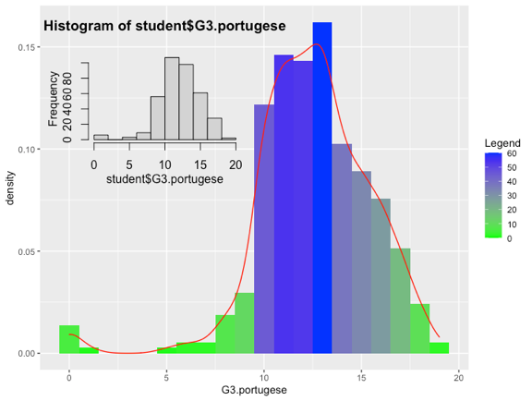

All the other numerical variables pass the normality test as well.

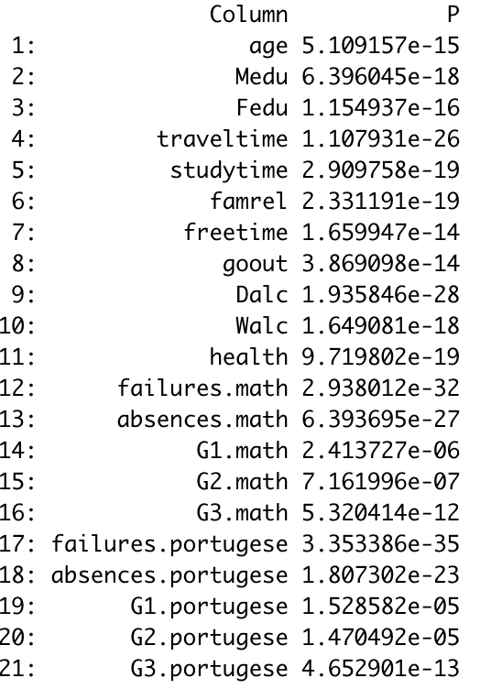

**Correlation Matrix:** A correlation matrix of all the numerical variables shows G1/G2 scores are highly correlated for both Math and Portuguese. Weekday and Weekend alcohol consumption is also highly correlated apart from education of the parents.

G1 and G2 scores are expected to be highly correlated due to the fact the final grades are determined using the prior evaluations of the course. Dropping these variables, the correlation matrix gives a stronger indication of other factors effecting final grades of the student, thus indicating “Left Out Variable Error” is avoided in this situation.

**Variable Selection:** Above observation leads us to a more formal way to choose certain variables over other empirically before proceeding further with EDA. Due to large number of parameters (33), variable contribution assessment could not be done using `olsrr` package in R, instead `leap` package was used to eliminate multicollinear research variables.

Based on the above exhaustive search of leap’s selection method, the final set of features that is selected are *school, sex, age, higher education, Dalc (weekday alcohol consumption), absences in Math, G3 Final Math grade and failures in Portuguese.*

**EDA:** Pair plot of the selected features color coded with red as Female and green as Male students, broadly shows inter-relation between all the features.

Students’ final math grade shows a positive correlation to final grade in portugese, generally applicable to brighter students. More male students consume alcohol in weekdays (implying weekends too because previously its shown that Dalc and Walc are strongly correlated) have negative correlation with their G3 grades, effecting language learnings more (-0.285) than their math abilities (-0.152). Absence in classes effects male students of their math grades more than female counterparts. However, higher absence in portugese classes (previously its shown that absence.math is highly correlated to absence.portugese) generally does not affect the final grade of the students. One school (GP) has lower variance in final grade compared to other school MP which also shows significant difference of grades between male and female students. While age is not very significant, higher education aspirations in females score higher than male counterparts. Slightest of alcohol consumption among males indicates high failure rate in both the courses (failures.math is significantly correlated (.5) with failures.portugese).

Females showing strong correlation of their math score with their language score so does the Males.

The below box and violin plot overview shows students having higher education aspirations has statistically significant variation in G3 final grades. There is more variation in grades of the males in school GP with few outliers, whereas MS’s portugese grade variations is gender agnostic with high variation and heavy lower bound outliers.

**Model:**

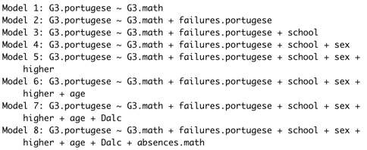Each of the selected feature variables are added one by one in the order of their correlation with G3.portugese, leading to the following evolution of a best fit line model.

*The best linear model is thus:*

$$\hat{y}= -0.32301 + 0.31273x_{1} - 1.44057x_{2} - 2.11560x_{3} - 1.10659x_{4} + 1.91890x_{5} + 0.58411x_{6} - 0.46871x_{7} - 0.05219x_{8}$$

$where \begin{aligned}x_{1}:G3.math \\ x_{2}: failures.portugese \\ x_{3}: school \\ x_{4}:sex \\ x_{5}:higher \\ x_{6}:age \\ x_{7}:Dalc \\ x_{8}:absences.math\end{aligned}$

Pictorial representation of the best line model fitting through G3.portugese collected samples. Females of school GP scores the highest considering all the significant parameters.

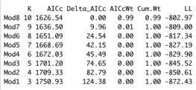**Model Quality: $R_{a}^{2}= .4686$**  meaning ~47% of the samples is explained by this model. $MSE=4.60$ low $AIC=1626$, randomness of the residuals with few outliers (QQ plot in figure below) showing homoscedasticity. Good VIFs of all the variables. PRESS statistic is 1779.98 and $R_{jack}^{2}= 0.4433$ meaning prediction is ~44% confident.

**Coefficients’ Interpretation of the model**: Following shows how the coefficients of different independent variables relate to dependent variable G3 Portuguese.

*Interpretation of each variable coefficient keep others constant:*

1. Math scores have one-to-one correspondence with Portuguese grades.
2. With every failure in Portuguese exam, the final grade is negatively affected by 1.44.
3. Students studying in School MS have relatively lower scoring on Portuguese in general by 2.11.
4. Males generally scoring less in portugese compared to Females by 1.11.
5. Higher education aspirations motivate students to score more in Portuguese by 1.9.
6. Age is positively related to final grade.
7. Alcohol consumption have quite an impact on learnings.
8. Absents in classes also lowers the final grade but not severely effects it.

**Model Predictions:** Each variables’ prediction showing tighter prediction interval around the lower range and getting slightly wider (less confident) on higher range of values.

More specifically, in the below figure, Alcohol consumption driving the prediction of final Portuguese score is consistent when students don’t have higher education aspiration for either of the school. However, part (B) shows prediction interval are tighter, meaning more confidence in predicting final grade, when Male or Female student have higher education aspiration for either of the school.

**5 CONCLUSIONS AND FUTURE WORK**

**Conclusion:**

We have seen Alcohol consumption does effect student performance but there are other more dominating reasons among Portuguese students behind scoring lower grades.

Higher Math score strongly suggests a better scoring probability in Portuguese language, more so for Females than Males, especially from school GP.

**Challenges:**

Due to many qualitative variables and correlation matrix methodology is insufficient for variable selection. Instead, a more robust method is required.

G1/G2 scores for both the subjects needs to be accommodated in some other manner and all the three grades together should become the response variable. Due to lack of knowing how these scores leads to final grade, this was avoided to not use interaction prior to model analysis.

**Future Work**: This dataset is collected from a single locality and probably suffer from sample bias. More school should be surveyed across regions to generalize the conclusion countrywide.

$R_{adj}^{2}$ showing ~50% unexplained portion in the model and therefore:

1. Try interaction models which are logical variables but got eliminated like studytime.
2. more sophisticated models explaining conditional decisions like parents’ education which is otherwise eliminated due to multicollinearity.
3. Incorporate some way to distinguish student’s general interest or potential in study instead of just education history

# Works Cited

Cortez, P., & Silva, A. (2008, April). *USING DATA MINING TO PREDICT SECONDARY SCHOOL STUDENT PERFORMANCE.* Retrieved from University Of Minho: http://www3.dsi.uminho.pt/pcortez/student.pdf

Pagnotta, F., & Amran, H. M. (2016). *Student Alcohol Consumption.* Retrieved from Data Society: https://data.world/data-society/student-alcohol-consumption

Spear, L. P. (2003, June). *Alcohol’s Effects on Adolescents .* Retrieved from National Institute on Alcohol Abuse and Alcoholism: https://pubs.niaaa.nih.gov/publications/arh26-4/287-291.htm

TPN/Lusa. (2021, May 21). *Portuguese consume 12 litres of pure alcohol annually*. Retrieved from The Portugal News: https://www.theportugalnews.com/news/2021-05-21/portuguese-consume-12-litres-of-pure-alcohol-annually/59951

**WEBLINKS**

1. <https://www.theportugalnews.com/news/2021-05-21/portuguese-consume-12-litres-of-pure-alcohol-annually/59951>
2. <https://data.world/data-society/student-alcohol-consumption>

1. (numeric: 0 - none, 1 - primary education (4th grade), 2 – 5th to 9th grade, 3 – secondary education or 4 – higher education)
2. 'teacher', 'health' care related, civil 'services' (e.g. administrative or police), 'at_home' or 'other'
3. : 1 - <15 min., 2 - 15 to 30 min., 3 - 30 min. to 1 hour, or 4 - >1 hour